Test Case: tc007_SPX_Dev5_Validacion_Boton_Edit_Administrador_Menu
Step 1 - Enter username and password and click to button Enter : Credentials Entered
Image file-name: QC_Testing-tc007_SPX_Dev5_Validacion_Boton_Edit_Administrador_Menu-nov. 20 2025, 05 38 52 p. m.

Step 2 - Select to UEN and Access to Administrador Roles Menu: UEN Correctly selected and Correct access
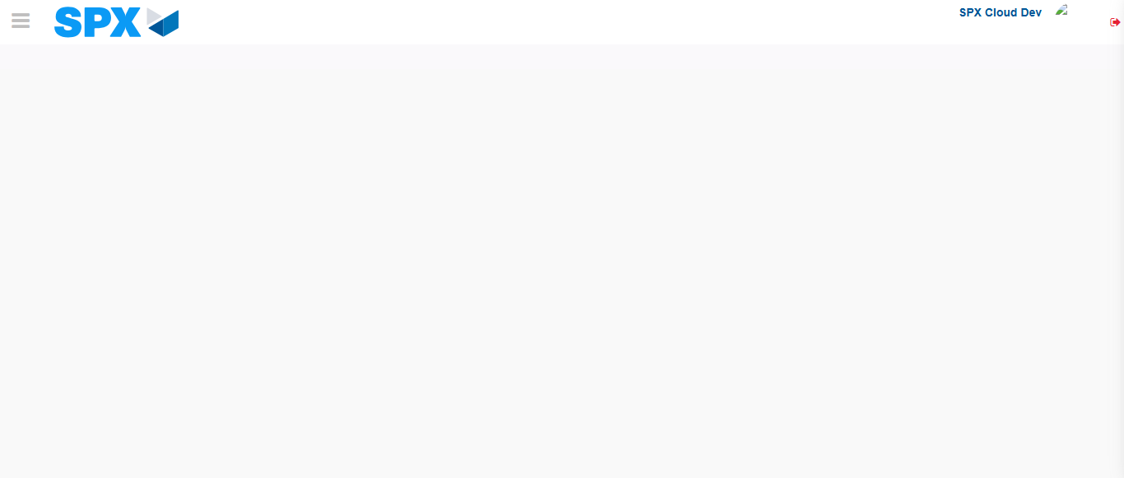Image file-name: QC_Testing-tc007_SPX_Dev5_Validacion_Boton_Edit_Administrador_Menu-nov. 20 2025, 05 39 01 p. m.

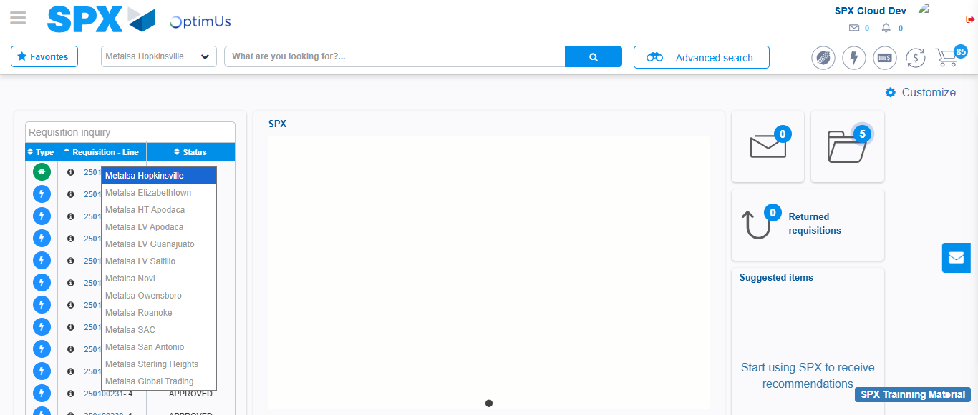Image file-name: QC_Testing-tc007_SPX_Dev5_Validacion_Boton_Edit_Administrador_Menu-nov. 20 2025, 05 39 02 p. m.

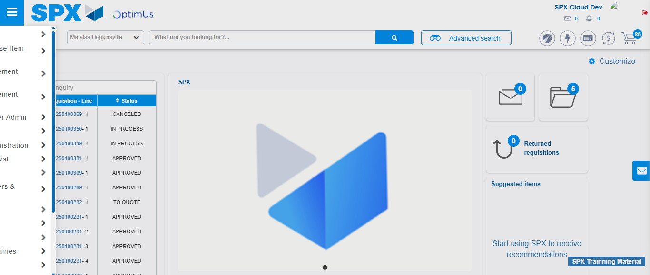Image file-name: QC_Testing-tc007_SPX_Dev5_Validacion_Boton_Edit_Administrador_Menu-nov. 20 2025, 05 39 13 p. m.

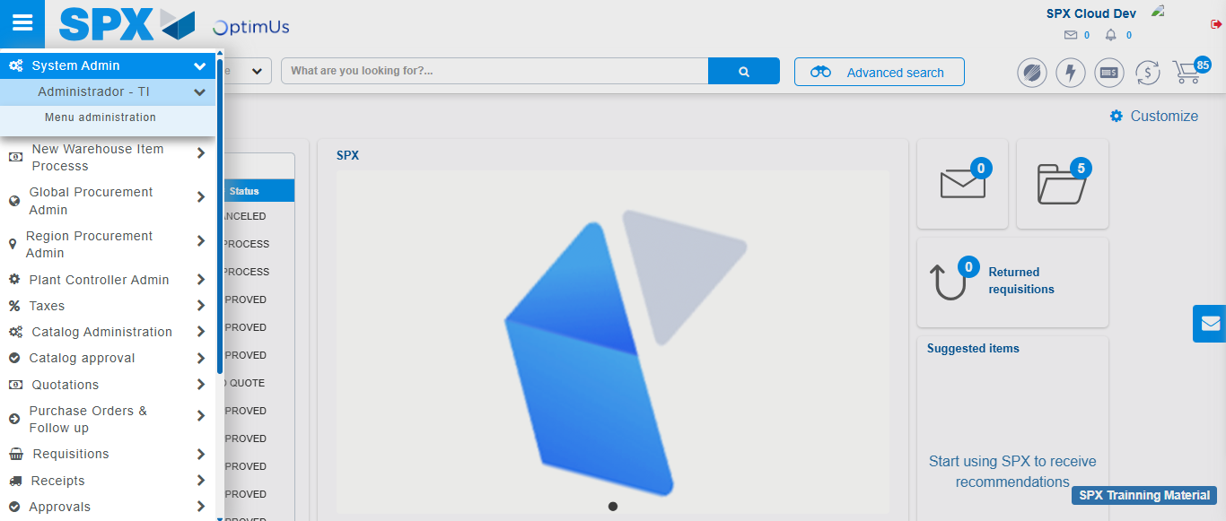Image file-name: QC_Testing-tc007_SPX_Dev5_Validacion_Boton_Edit_Administrador_Menu-nov. 20 2025, 05 39 14 p. m.

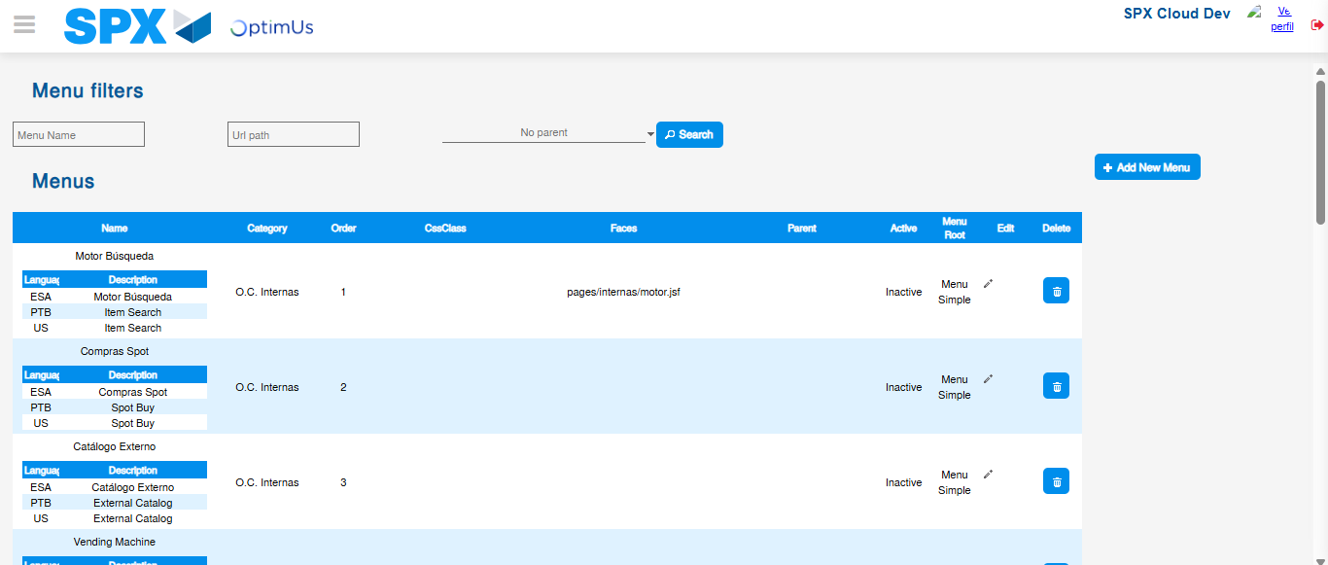Image file-name: QC_Testing-tc007_SPX_Dev5_Validacion_Boton_Edit_Administrador_Menu-nov. 20 2025, 05 39 16 p. m.

Step 3 - Add new menu and edit fields: New menu successfully registered
Image file-name: QC_Testing-tc007_SPX_Dev5_Validacion_Boton_Edit_Administrador_Menu-nov. 20 2025, 05 39 16 p. m.

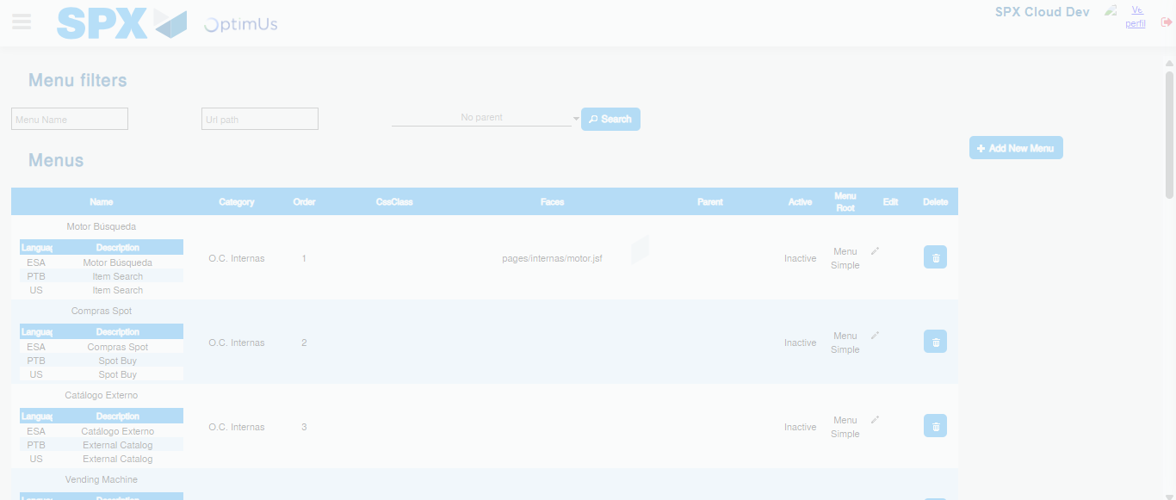Image file-name: QC_Testing-tc007_SPX_Dev5_Validacion_Boton_Edit_Administrador_Menu-nov. 20 2025, 05 39 17 p. m.

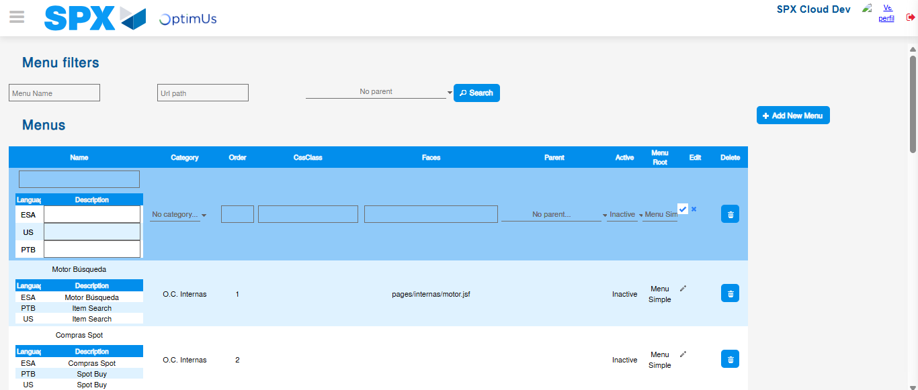Image file-name: QC_Testing-tc007_SPX_Dev5_Validacion_Boton_Edit_Administrador_Menu-nov. 20 2025, 05 39 20 p. m.

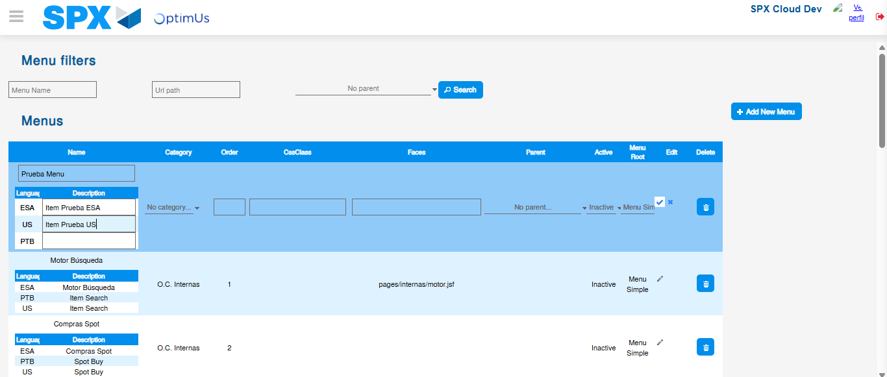Image file-name: QC_Testing-tc007_SPX_Dev5_Validacion_Boton_Edit_Administrador_Menu-nov. 20 2025, 05 39 21 p. m.

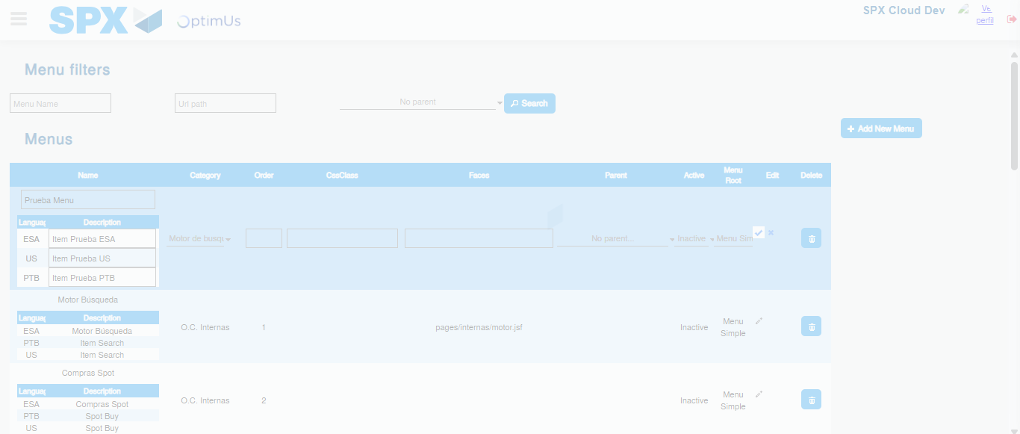Image file-name: QC_Testing-tc007_SPX_Dev5_Validacion_Boton_Edit_Administrador_Menu-nov. 20 2025, 05 39 22 p. m.

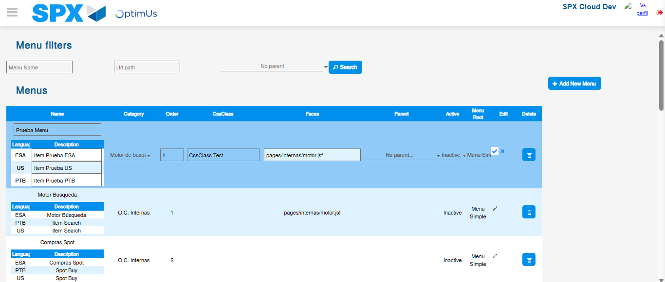Image file-name: QC_Testing-tc007_SPX_Dev5_Validacion_Boton_Edit_Administrador_Menu-nov. 20 2025, 05 39 23 p. m.

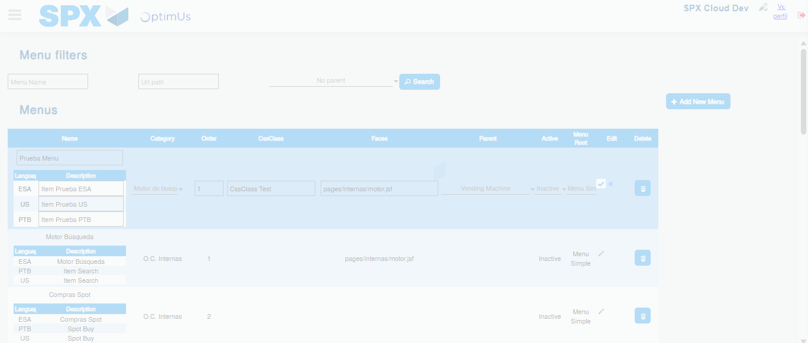Image file-name: QC_Testing-tc007_SPX_Dev5_Validacion_Boton_Edit_Administrador_Menu-nov. 20 2025, 05 39 24 p. m.

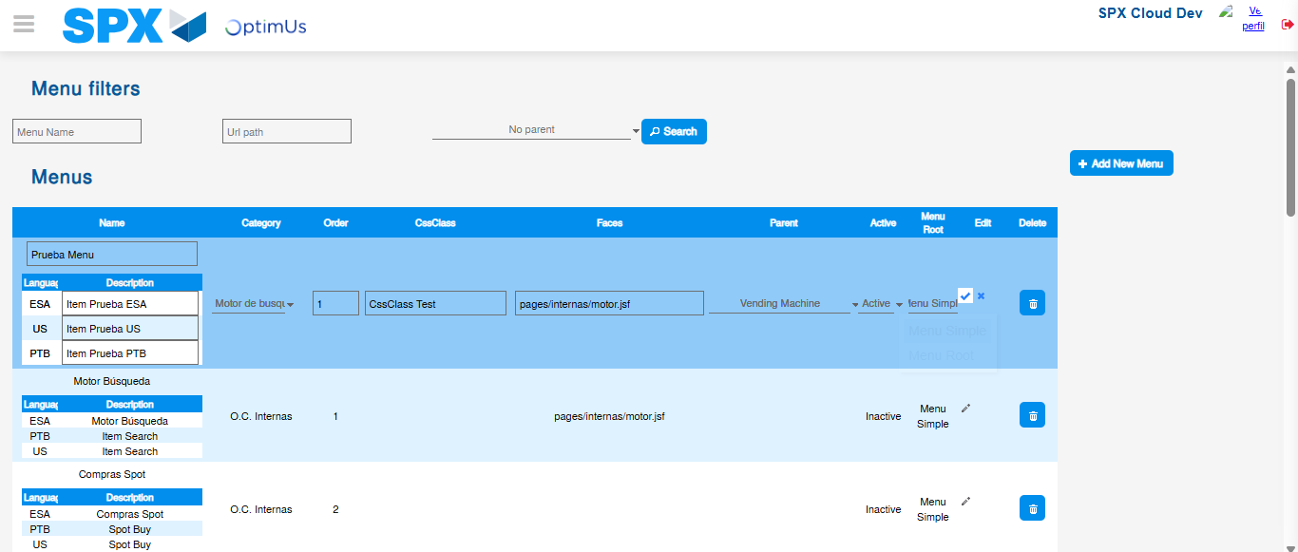Image file-name: QC_Testing-tc007_SPX_Dev5_Validacion_Boton_Edit_Administrador_Menu-nov. 20 2025, 05 39 25 p. m.

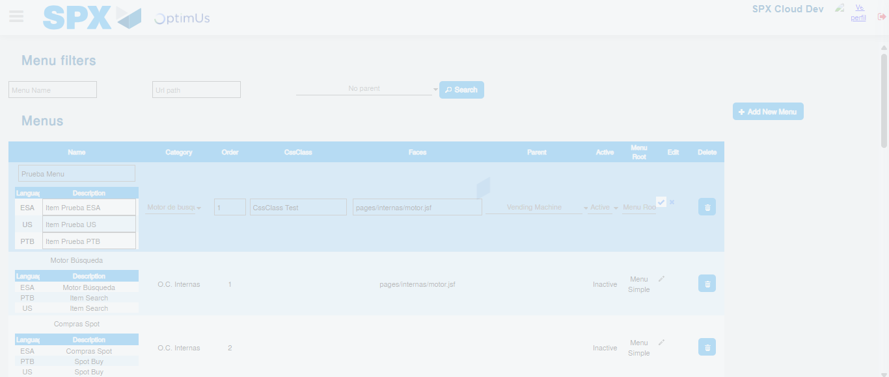Image file-name: QC_Testing-tc007_SPX_Dev5_Validacion_Boton_Edit_Administrador_Menu-nov. 20 2025, 05 39 26 p. m.

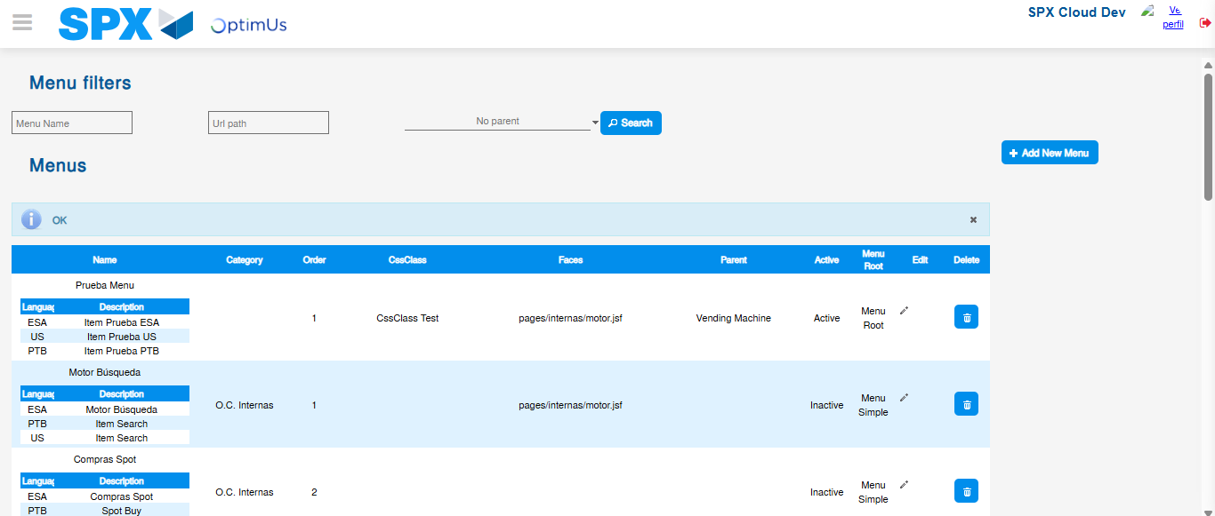Image file-name: QC_Testing-tc007_SPX_Dev5_Validacion_Boton_Edit_Administrador_Menu-nov. 20 2025, 05 39 29 p. m.

